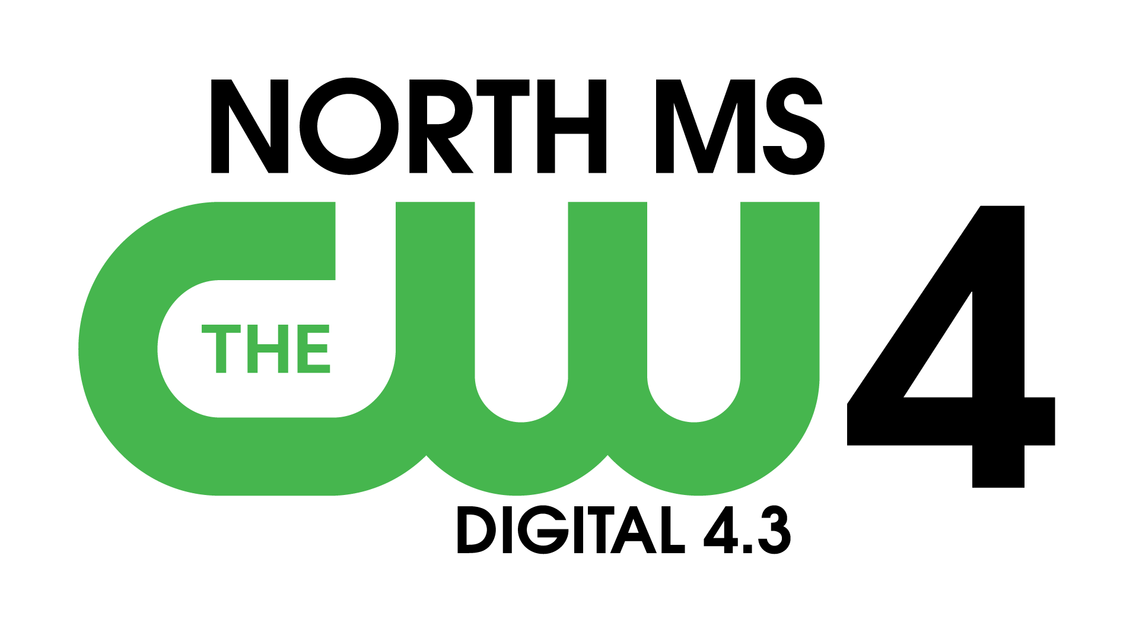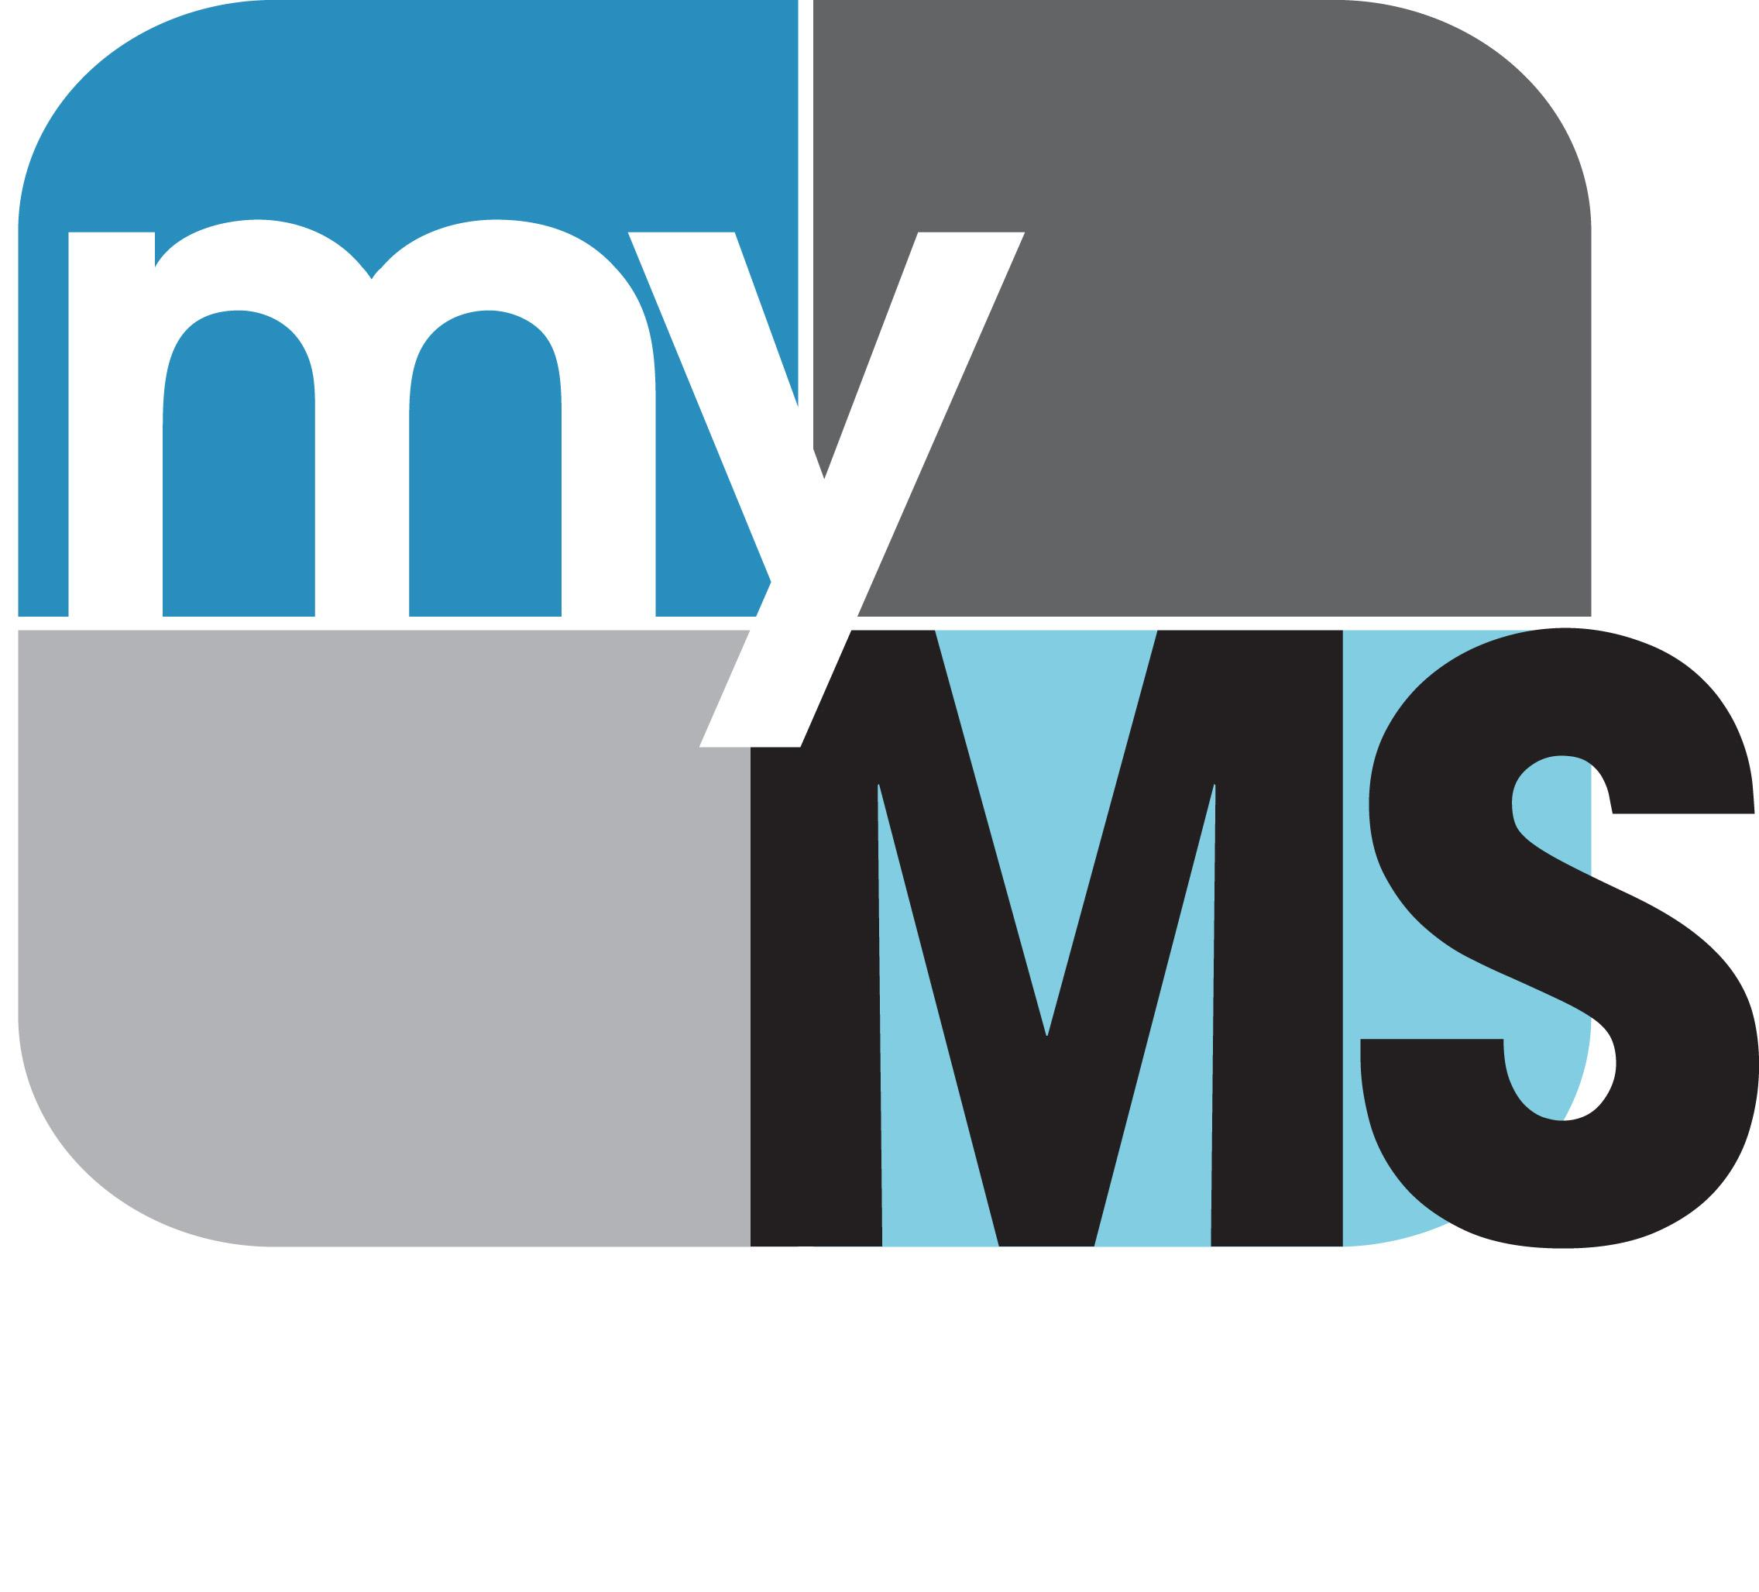

JOB FAIR 2024

Join us at the

Columbus Place

in Columbus, Mississippi

February 22nd, 2024 | 10 am - 1 pm

This in person Job Fair will be held indoors!

**Vendor Setup begins at 9am**

Partnership Option #1: $300

1 - 8x10 Booth space and 2 chairs

Website listed on Job Fair Page at WCBI.com

OR

Partnership Option #2: $700

1 - 8x10 booth space and 2 chairs

Website listed on Job Fair Page at WCBI.com

30 - :30 sec commercial spots to help promote your business.

Sign Your Business Up to Participate Today!

Option #_____

____________________________________ ___________________
Signature Date

____________________________________ ___________________
Business Phone Number

